UNITED STATES
SECURITIES AND EXCHANGE COMMISSION
WASHINGTON, DC 20549
SCHEDULE 14A
(Rule 14a-101)
SCHEDULE 14A INFORMATION
Proxy Statement Pursuant to Section 14(a) of the
Securities Exchange Act of 1934
Filed by the registrant ☒ |  |  |  |  |  |  |  |  | Filed by a party other than the registrant ☐
Check the appropriate box:
☐ |  |  |  |  |  |  |  |  | Preliminary Proxy Statement
☐ |  |  |  |  |  |  |  |  | Confidential, for use of the Commission only (as permitted by Rule 14a-6(e)(2))
☐ |  |  |  |  |  |  |  |  | Definitive Proxy Statement
☒ |  |  |  |  |  |  |  |  | Definitive Additional Materials
☐ |  |  |  |  |  |  |  |  | Soliciting Material Pursuant to §240.14a-12
MIMEDX GROUP, INC.
(Name of registrant as specified in its charter)

Payment of the filing fee (check the appropriate box):
☒ |  |  |  |  |  |  |  |  | No fee required.
☐ |  |  |  |  |  |  |  |  | Fee paid previously with preliminary materials.
☐ |  |  |  |  |  |  |  |  | Fee computed on table in exhibit required by Item 25(b) per Exchange Act Rules 14a–6(i)(1) and 0–11

1
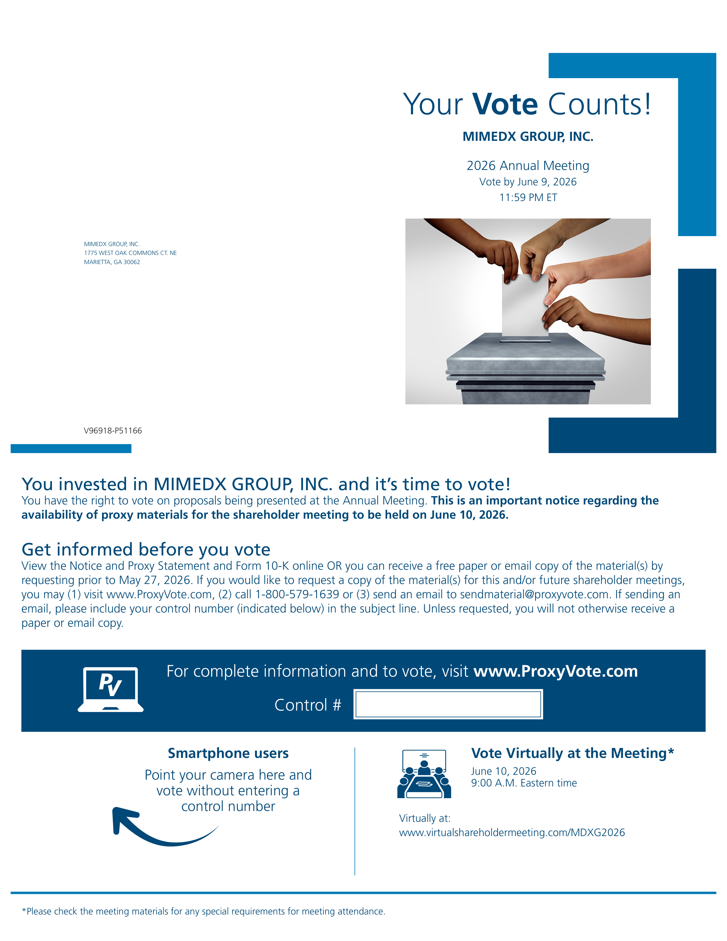
2
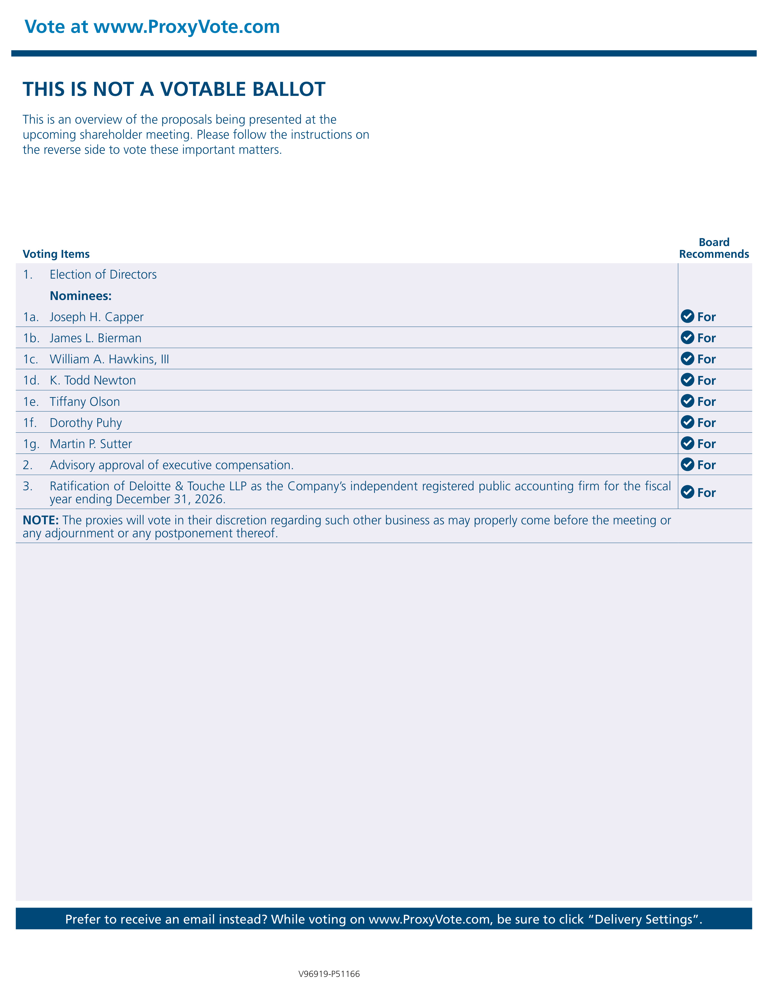
3

